ACE INSTITUTE OF MANAGEMENT

Pokhara University

Faculty of Management



Bachelor in Computer System and Information Technology (BCSIT)

PROPOSAL ON Project “CareConnect”

Course: Project II (PRJ 281) Year/Semester: III/IV

Submitted to:
Sanju Shrestha

Submitted by:
Name: Jenisha Karmacharya, Ocean Pandey,
Shreya Maharjan

Abstract
CareConnect is a web-based Smart Donation and Volunteer Management System developed to connect donors, volunteers, and non-governmental organizations (NGOs), through a centralized digital platform. The system addresses challenges associated with traditional donation and volunteer management processes, including poor communication, lack of transparency, inefficient record management, and difficulties in volunteer coordination. CareConnect provides features such as donation management, volunteer registration, event participation, organization dashboards, reporting, and notification services.
The system is developed using modern web technologies and follows the Agile Software Development methodology. It aims to simplify social service activities by providing a secure, transparent, and user-friendly platform that enhances collaboration between stakeholders. The project is expected to improve community engagement, increase accountability, and support charitable organizations in managing their activities more efficiently.

Acknowledgement
We would like to express our sincere gratitude to our project supervisor, Ms. Sanju Shrestha, for his continuous guidance, encouragement, and valuable suggestions throughout the development of this project.
We would also like to thank Pokhara University, for providing us with the opportunity and resources to undertake this project as part of the Bachelor in Computer System and Information Technology (BCSIT) program.
Special thanks go to our friends, classmates, and family members for their support and motivation during the completion of this project.
Finally, we would like to acknowledge everyone who contributed directly or indirectly to the successful completion of the CareConnect project.

Table of Contents

Chapter | Contents | Page No.
Abbreviations |  | v
List of Figures |  | vi
List of Tables |  | vii
Chapter 1 | Introduction
 | 1.1 Background | 8
 | 1.2 Statement of problem | 9
 | 1.3 Objectives | 10
 | 1.4 Scope | 11
 | 1.5 Limitations | 11
Chapter 2 | Review of Literature
 | 2.1 Fundamental Theories and Concept | 12
 | 2.1.1Web-Based Information Systems | 12
 | 2.1.2 User Authentication and Authorization | 12
 | 2.1.3Donation Management System | 12
 | 2.1.4 Volunteer Management System | 12
 | 2.1.5 Notification and Communication Systems | 12
 | 2.2 Review of Similar Projects and Theories | 13-14
 | 2.3 Research Gap | 14
Chapter 3 | System Analysis and Design
 | 3.1 Requirement Analysis | 15
 | 3.1.1 Functional Requirement | 15-17
 | 3.1.2 Non-Functional Requirement | 18
 | 3.2. Feasibility Study | 19
 | 3.3 Data Modeling | 20-21
 | 3.4 Process Modeling | 22
 | 3.5 System Design | 23
Chapter 4 | Implementation and Testing
 | 4.1 Implementation | 24
 | 4.2 Tools Used | 24
 | 4.3 Implementation Details of Modules | 24-25
 | 4.4 Testing | 25
Chapter 5 | Conclusion and Future Recommendations
 | 5.1 Lesson Learnt | 26
 | 5.2 Conclusion | 26
 | 5.3 Recommendations | 26
Appendices |  | 27-32
References |  | 33

Abbreviations
The Abbreviations presents the shortened forms and acronyms used throughout this report along with their full meanings. It serves as a reference guide for readers, helping them understand technical terms, technologies, and organizational terminologies used in the CareConnect project. It improves readability, reduces repetition of lengthy terms, and ensures consistency in the documentation by providing a clear explanation of commonly used abbreviations.
Abbreviation | Meaning
NGO | Non-Governmental Organization
UI | User Interface
DBMS | Database Management System
HTML | HyperText Markup Language
CSS | Cascading Style Sheets
JS | JavaScript
SDLC | Software Development Life Cycle
CRUD | Create, Read, Update and Delete

List of Figures

Figure 1: Use Case Diagram 18
Figure 2: ER Diagram 22
Figure 3: Flowchart 23
Figure 4: System Architecture 24
Figure 5: Home Page 28
Figure 6: Donate Page 29
Figure 7: Volunteer Page 30
Figure 8: NGO Page 31
Figure 9: Contact Page 32
Figure 10: Sign Up Module 33
Figure 11: Sign in module 33

List of Tables
Table 1 26

Chapter 1: Introduction
1.1 Background
CareConnect is a web-based Smart Donation and Volunteer Management System designed to connect donors, volunteers and charitable organizations through a single digital platform. In today’s world, many people are interested in helping others and supporting social causes such as orphanages, old age homes, disaster relief programs, and community welfare campaigns. However, people often face difficulties in finding a trusted and organized platform where they can easily donate money, provide necessary items, or participate in volunteer activities. Similarly, many NGOs and charity organizations struggle to manage donations, coordinate volunteers, maintain records, and communicate effectively with supporters.
With the rapid growth of internet access and digital technology, online platforms have become more practical, accessible, and efficient for social service activities. People now prefer digital systems that are fast, secure, transparent, and easy to use. CareConnect aims to use technology to bridge the gap between donors, volunteers, and organizations by providing a centralized platform where all activities can be managed smoothly.
The main purpose of CareConnect is to create a secure, transparent and reliable environment for social contribution. Through this platform, users will be able to register as donors or volunteers, donate money or items, join social events and campaigns, and track their activities in real time. Organizations will also be able to post their needs, manage volunteers, monitor donations, and maintain proper records efficiently. The system will include features such as user registration, donation management, volunteer coordination, event participation, notifications, and reporting.
CareConnect not only helps organizations reduce manual work and improve efficiency, but also encourages more people to participate in social causes by making the process simple and convenient. By improving communication, transparency, and coordination among all stakeholders, the platform aims to increase social impact and build stronger community support.

1.2 Statement of Problem
Many charity organizations, NGOs, orphanages, and social service groups still use traditional and manual methods to manage donations, volunteers and events. These methods are often slow, difficult to manage, and less effective, especially when handling a large number of activities and users.
The major problems faced by existing systems are:
- Lack of Proper Communication
  - Poor coordination between donors, volunteers, and organizations
  - Difficulty in managing announcements and notifications
- Manual and Inefficient Record Management
  - Donation records are often managed manually
  - High chances of data errors, duplication, and loss of information
- Lack of Transparency
  - Donors cannot easily track how their donations are used
  - Reduced trust and confidence among users
- Volunteer Management Difficulties
  - Volunteers face problems finding suitable campaigns or events
  - Organizations find it difficult to manage volunteer schedules and participation
CareConnect aims to solve these problems by providing a Smart Donation and Volunteer Management System that connects donors, volunteers, and organizations through a single integrated web platform. The system will improve transparency, communication, coordination, and resource management while reducing manual work and increasing social impact.

1.3 Objectives of the Study
The main objective of the CareConnect Smart Donation and Volunteer Management System is to design and develop an integrated digital platform that improves the way donations, volunteers, and charitable organizations interact and coordinate. The system aims to make social service activities more efficient, transparent and user-friendly by using modern web technologies.
The specific objectives of this project are:
- To develop a centralized platform
- To connect all stakeholders in one system
- To simplify the donation process
- To support organizations in managing needs
- To improve volunteer coordination
- To ensure transparency and accountability
- To enhance organization of social services
- To improve communication and engagement

1.4 Scope of the Study
The CareConnect project focuses on creating a platform that connects donors, volunteers, and NGOs in one system. It mainly includes donation management, volunteer registration, NGO activity handling, and event participation. Users can securely register and log in, allowing different roles like donor, volunteer, and NGO to access relevant features easily.
The system also provides reporting, communication, and notification services to improve coordination and transparency. NGOs can manage activities and track progress, while users receive updates about donations, events, and announcements. Overall, the scope is to make social welfare activities more organized, efficient, and accessible through a digital platform.
1.5 Limitations of the study
- The study is limited by time constraints, which restricted deeper research and full feature development.
- It is based on a student-level project, so it does not include all advanced or enterprise-level functionalities.
- Limited resources (tools, data, and technologies) affected the overall depth and scope of the system.
- The system uses simulated or limited test data, which may not fully represent real-world usage.
- Real-time processing and advanced analytics features are either limited or not fully implemented.
- Scalability testing and handling of large user loads were not extensively performed.

Chapter 2: Literature Review
2.1 Fundamental Theories and Concepts
2.1.1 Web-Based Information Systems
CareConnect is based on a web-based information system architecture, which allows users to access services through a browser without installing additional software. Such systems typically use client-server architecture where the frontend handles user interaction and the backend manages data processing and storage.
2.1.2 User Authentication and Authorization
Authentication ensures that only registered users can access the system, while authorization controls what each user is allowed to do. This is essential in CareConnect to distinguish between donors, volunteers, and administrators.
2.1.3 Donation Management Systems
Donation management systems are platforms designed to facilitate transparent and efficient handling of donations. They help track contributions, manage donors, and ensure proper allocation of resources.
2.1.4 Volunteer Management Systems
Volunteer management systems help organizations register, schedule, and coordinate volunteers for different activities and events. These systems improve communication and resource allocation.
2.1.5 Notification and Communication Systems
Modern web applications integrate email or messaging services to send notifications. CareConnect uses such mechanisms to inform users about events, donations, and updates.

2.2 Review of Similar Projects and Systems
To understand the current approaches used in donation and volunteer management, several existing platforms were studied:
GoFundMe
https://www.gofundme.com/
GoFundMe is a global crowdfunding platform used mainly for personal fundraising and charitable causes. Users can create campaigns to raise money for medical emergencies, education, disaster relief, and social causes. It allows individuals to share campaigns through social media and receive donations online. However, it is mostly focused on money-based fundraising, and has limited structured volunteer or organization management features.
VolunteerMatch
https://www.volunteermatch.org/
VolunteerMatch is a platform designed to connect volunteers with nonprofit organizations. It allows organizations to post volunteer opportunities, and individuals can search and apply based on location, interest, and skills. However, it mainly focuses on volunteering only, and does not support donation collection or integrated fundraising tools.
Salesforce Nonprofit Cloud
Salesforce Nonprofit Cloud | Salesforce
Salesforce Nonprofit Cloud is a comprehensive management system for large nonprofit organizations. It provides tools for donor management, fundraising tracking, campaign management, and analytics. It is very powerful but is often considered expensive and complex to implement, making it more suitable for large-scale organizations rather than small NGOs or community groups.

Charity Naviagtor
https://www.charitynavigaor.org/
Charity Navigator is a platform that evaluates and rates nonprofit organizations based on financial health, transparency, accountability, and performance. It helps donors decide which charities are trustworthy. However, it does not provide fundraising or volunteer coordination features; it is mainly an information and rating system for donors.
2.3 Research Gap
From the review of existing systems, several gaps have been identified:
- Lack of unified platforms combining donation, volunteer, and event management.
- Limited transparency in local NGO systems.
- Poor user experience in many existing systems.
- Lack of real-time communication and notification features.
- Minimal reporting and analytics features for NGOs
CareConnect aims to address these gaps by providing a centralized, user-friendly, and transparent platform.

Chapter 3: System Analysis and Design
3.1 Requirement Analysis
The CareConnect system is designed as a web-based donation and volunteer management platform that connects donors, volunteers, and NGOs. The main requirements were identified through analysis of existing manual and semi-digital donation systems.
3.1.1 Functional Requirements
Functional requirements describe the main services and operations that the system performs.
- User Registration and Role Management
- Users can register and log in securely
- Role-based access for Donor, Volunteer, NGOs/ Organization and Admin
- Different dashboards based on user roles
- Donation Management
- Users can donate money and essential items
- Donation submission and tracking system
- Maintain donation history and records
- Volunteer Registration
- Volunteers can register and create profiles
- Apply for available volunteer opportunities
- Track participation in events

- Organization Dashboard
- Organizations can manage their activities
- Post donation requests and volunteer opportunities
- Track donations and volunteer applications
- Event Management
- Create and manage events
- Users can join and participate in events
- Track event progress and status
- Transparent Donation Records and Reports
- Maintain detailed records of all donations
- Generate reports for accountability and transparency
- Dashboard and Analytics
- Donor dashboard to view contributions and history
- Admin dashboard with system overview and insights
- Display basic analytics such as donations and participation trends
- Communication and Notification System
- Email notifications to donors about donations and updates
- Alerts for events and activities

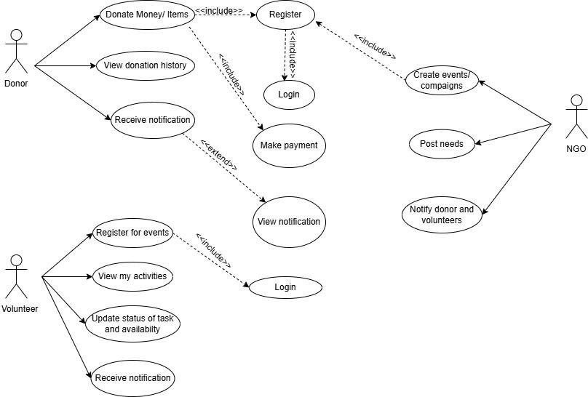
Figure 1: Use Case Diagram

3.1.2 Non-Functional Requirements
Non-functional requirements define the quality and performance aspects of the system.
- Security
- Secure authentication system with password protection
- Role-based access control to prevent unauthorized access
- Performance
- Fast response time for user requests
- Efficient handling of multiple users and transactions
- Usability
- Simple and user-friendly interface
- Easy navigation for donors, volunteers, and organizations
- Reliability
- System ensures accurate donation and volunteer records
- Minimal system downtime
- Scalability
- System can handle increasing number of users and data
- Can be expanded with new features in future
- Maintainability
- Easy to update and modify system features
- Modular design for better maintenance
3.2 Feasibility Analysis
1. Technical Feasibility
The system is technically feasible using modern web technologies such as HTML, CSS, JavaScript, and backend frameworks like Node.js or PHP with MySQL database support.
2. Operational Feasibility
The system is user-friendly and can be easily operated by donors, volunteers, and NGOs with minimal training.
3. Financial Feasibility
The project requires minimal cost as it uses open-source technologies and existing development tools.
4.Schedule Feasibility
The system can be developed within the academic project timeline using phased development (analysis, design, implementation, testing).

3.3 Data Modeling
The data model for CareConnect is designed to support a unified platform where NGOs, donors, and volunteers interact. It captures user management, fundraising campaigns, monetary and in-kind donations, volunteer engagement, and public inquiries. The schema ensures traceability of donations, verification of NGOs, and role-based access.
Key Entities and Relationships:
- Users serve as the central identity, holding login credentials and role information (e.g., donor, NGO admin, platform admin).
- NGOs are linked to users who manage them, storing registration details, focus area, verification status, and contact information.
- Causes represent fundraising campaigns created by NGOs, tracking financial goals and amounts raised.
- Donations record monetary contributions from users to specific causes, including payment status and frequency (one-time or recurring).
- Item Donations handle physical goods, capturing item descriptions, meetup logistics, and status.
- Volunteers store user availability, skills, and application status for NGO opportunities.
- Contact Messages capture public inquiries and newsletter subscriptions.
- A separate token table (appears as repeated index entries) manages password resets.
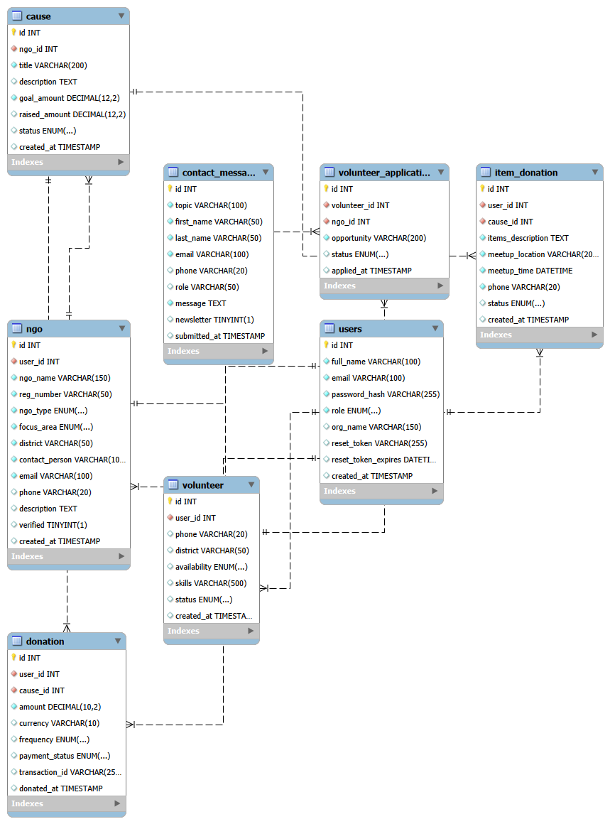
Figure 2: ER Diagram

  - Process Modeling
Process modeling describes system workflows:
- User registration → login → dashboard access
- Donor selects donation type → submits donation → confirmation
- NGO creates event → volunteers register → participation tracking
- Admin monitors system activity and generates reports
Figure 3: Flowchart
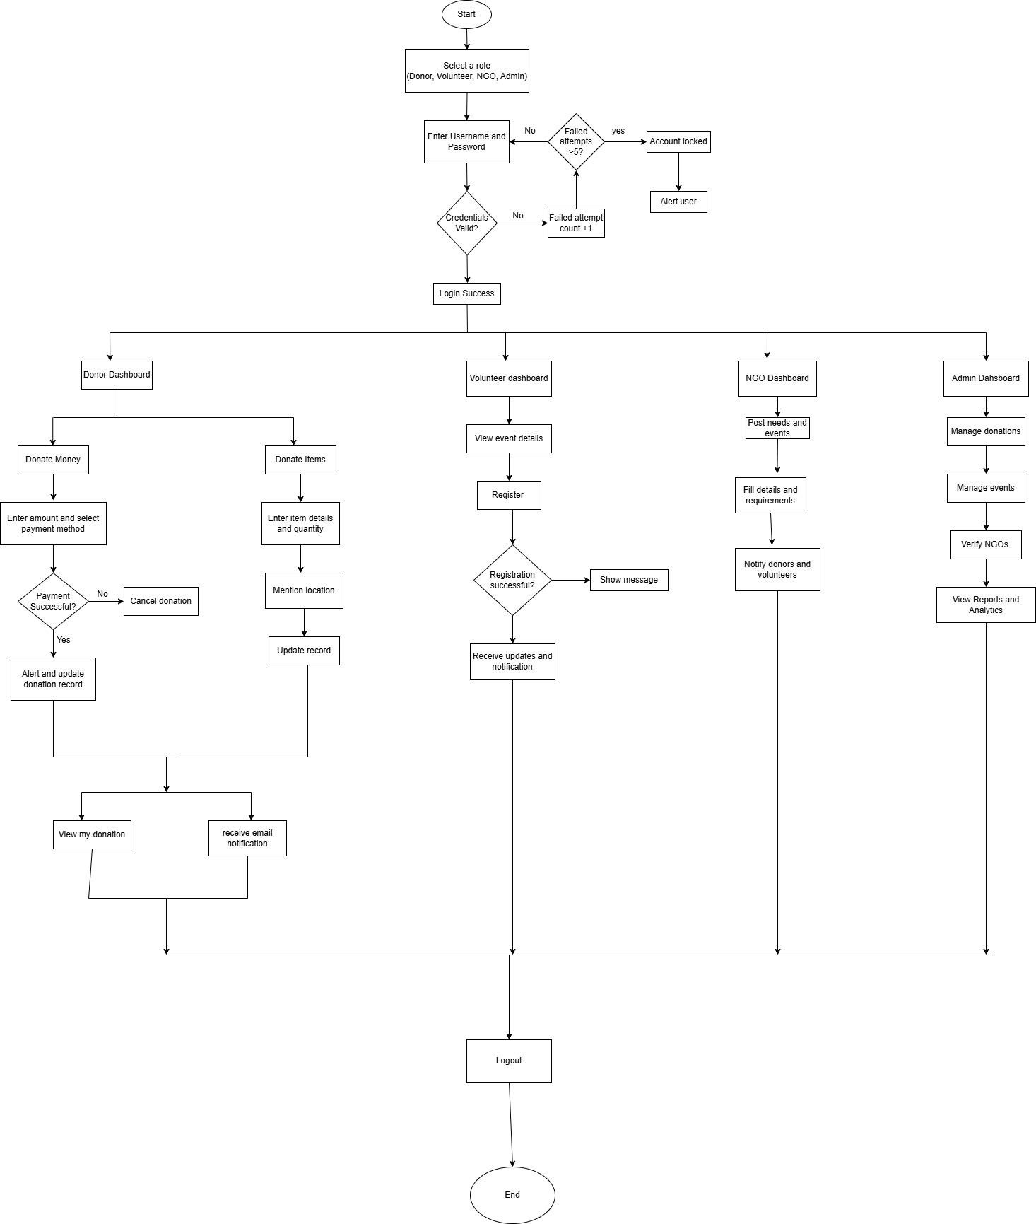

  - System Design
    - Architectural Design
CareConnect follows a 3-tier architecture:
- Presentation Layer (Frontend: HTML, CSS, JavaScript)
- Application Layer (Backend logic and processing)
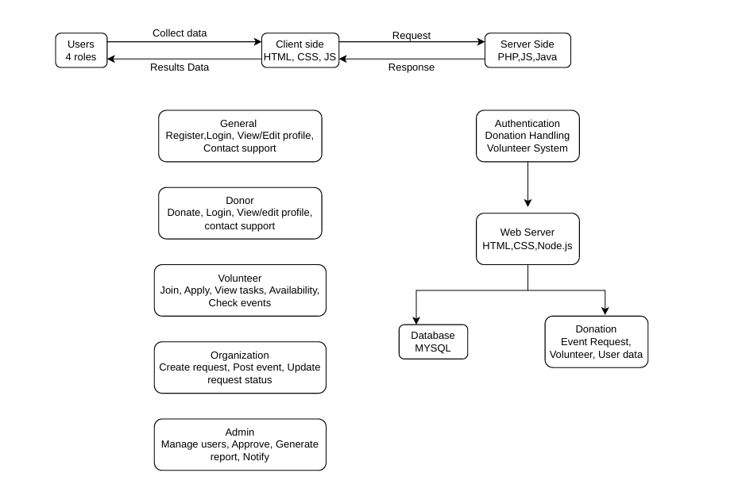
- Data Layer (Database: MySQL)
Figure 4: System Architecture

Chapter 4: Implementation and Testing
4.1 Implementation
The CareConnect project is currently in the implementation phase. At this stage, the system includes a fully designed user interface (UI) and a completed database schema. The backend logic and full system integration are still under development.
The implementation focuses on:
- Designing responsive web pages for users (donor, volunteer, NGO)
- Creating and structuring the relational database
- Preparing system modules for future backend integration
4.2 Tools Used
The following tools and technologies were used in the current phase:
- Frontend Technologies: HTML5, CSS3, JavaScript
- Database Platform: MySQL (via MySQL Workbench / phpMyAdmin)
- Editor: Visual Studio Code
- Browser: Chrome (testing UI)
4.3 Implementation Details of Modules
At this stage, only the UI and database modules are implemented.
1. User Interface Module
- Login and registration pages designed
- Dashboard layouts for donor, NGO, and volunteer
- Navigation bar and homepage structure completed
2. Database Module
- Tables created for users, NGOs, donations, causes, volunteers, and messages
- Relationships defined using foreign keys
- Data structure prepared for system integration
3. Donation UI Module
- Donation form UI created
- Input fields prepared for future backend processing
4. Volunteer UI Module
- Volunteer registration form designed
- Application UI for NGOs created
4.4 Testing
Testing has been performed only on the frontend and database structure since backend integration is not yet completed.
Table 1
Test Case | Description | Result
UI Load Test | Check if all pages load correctly | Passed
Form Input Test | Check validation of forms | Partially Passed
Navigation Test | Check page linking | Passed
Database Connection Test | Verify tables creation | Passed

Chapter 5: Conclusion and Future Recommendations

5.1 Lesson Learnt
During the development of the CareConnect project, several important concepts were learned, including:
- Designing user-friendly interfaces using HTML, CSS, and JavaScript
- Structuring relational databases using MySQL
- Understanding system design concepts such as ER diagrams and data modeling
- Importance of modular development and planning before implementation

5.2 Conclusion
The CareConnect project is currently in its early development stage. The UI design and database structure have been successfully completed. Although the system is not fully functional yet, the foundation has been properly built for future backend integration and system development.
The project aims to provide a platform for donation management, volunteer coordination, and NGO activities in a centralized system.

5.3 Recommendations
To improve and complete the system in the future, the following improvements are suggested:
- Development of backend functionality using PHP or Node.js
- Integration of secure authentication system
- Payment gateway integration for donations
- Real-time notification system
- Improved UI/UX for better user experience
Appendices
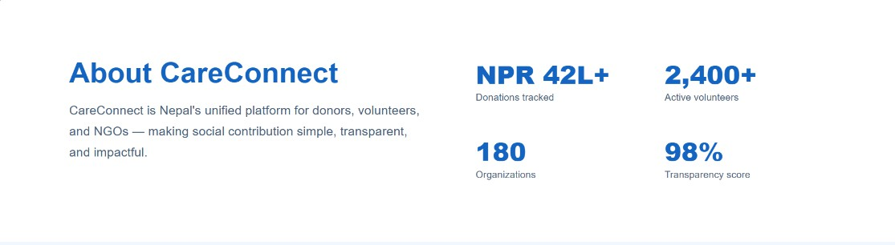
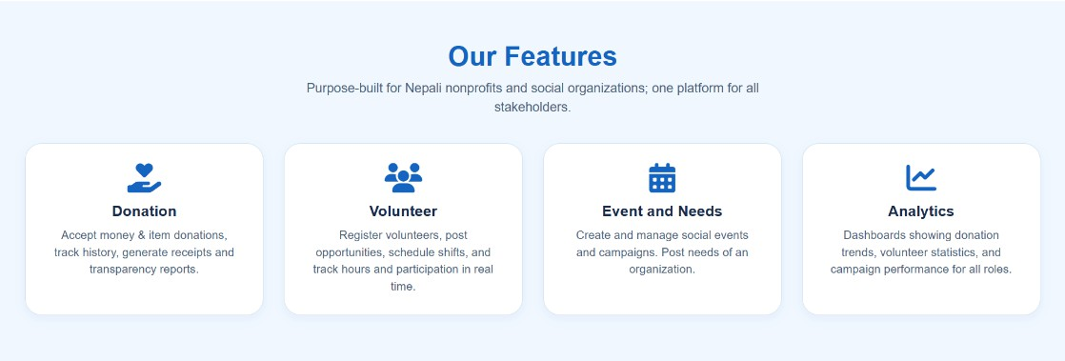
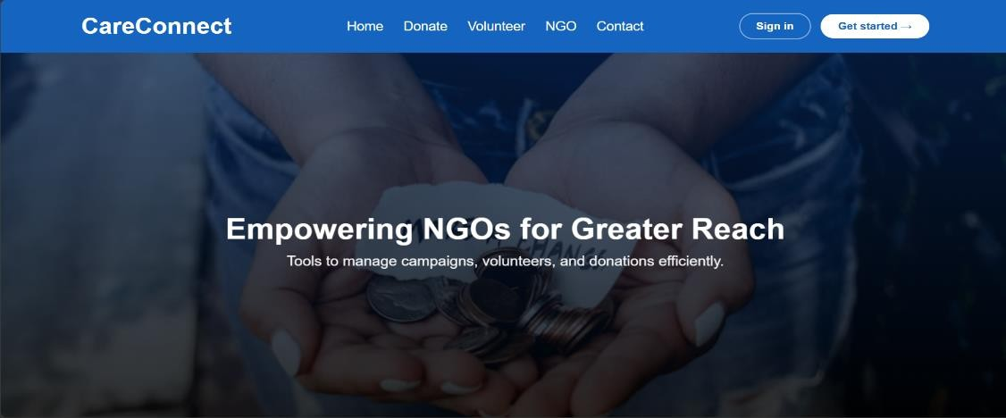
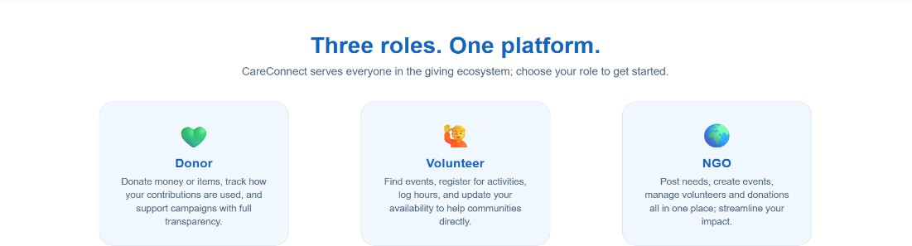
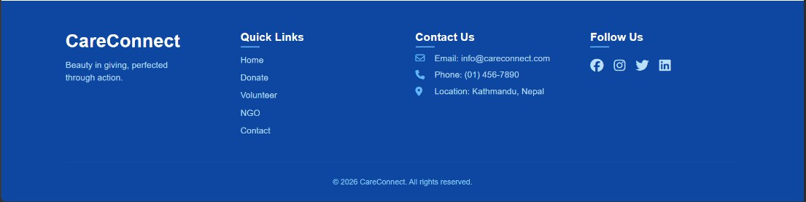
In this section, screenshots of the CareConnect project are included to provide visual evidence of the system’s development and functionality. These screenshots represent different parts of the project such as the user interface, including the homepage, login and registration pages, and donation and volunteer modules.
Figure 5: Home Page
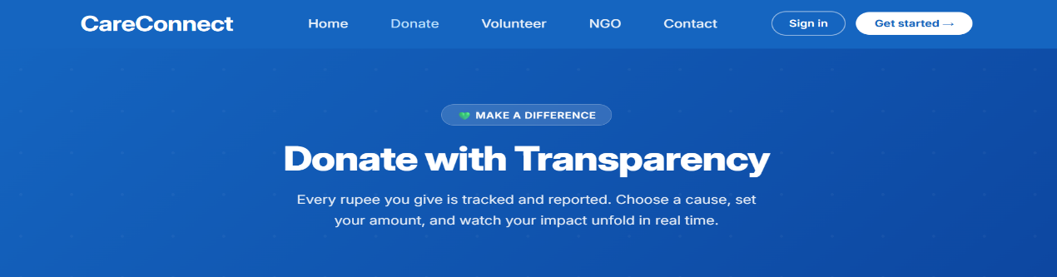
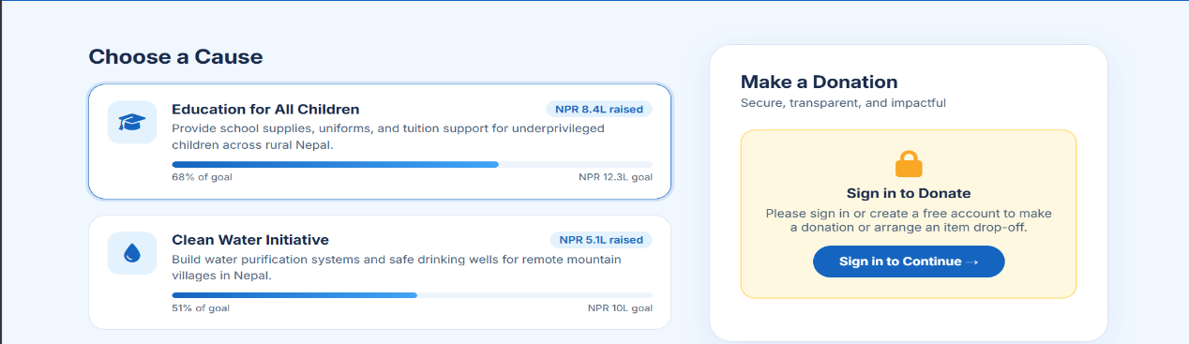
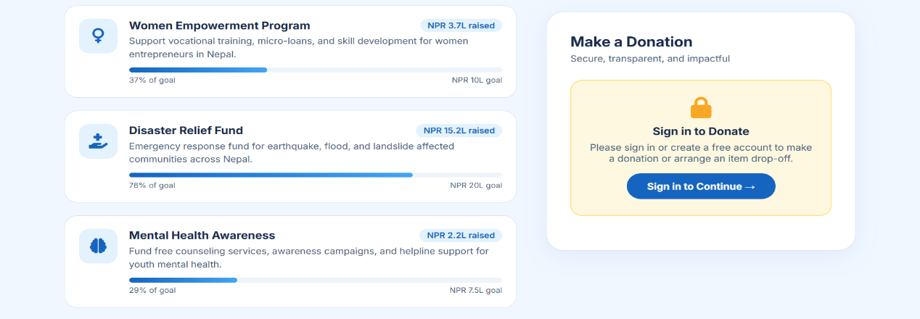
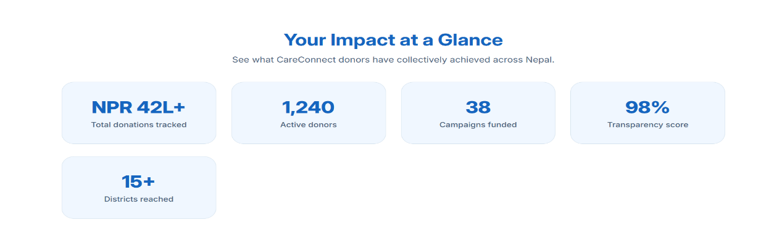
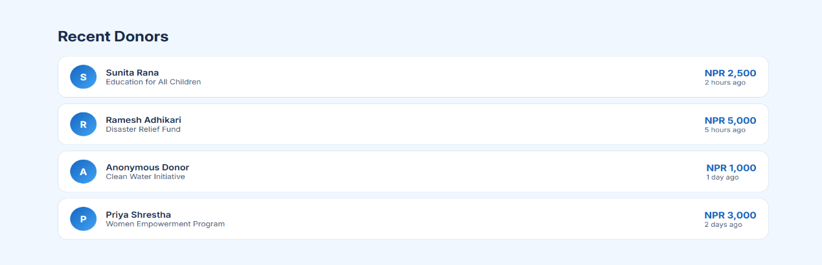
Figure 6: Donate Page
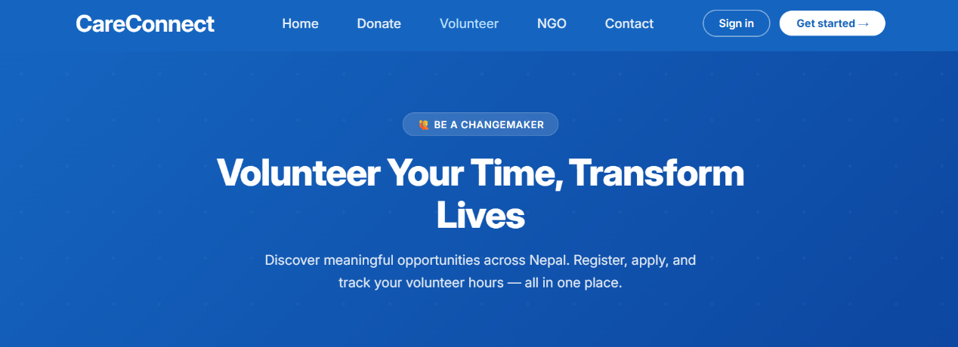
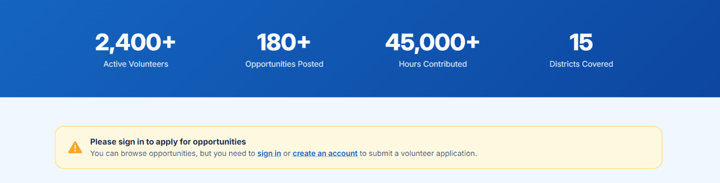
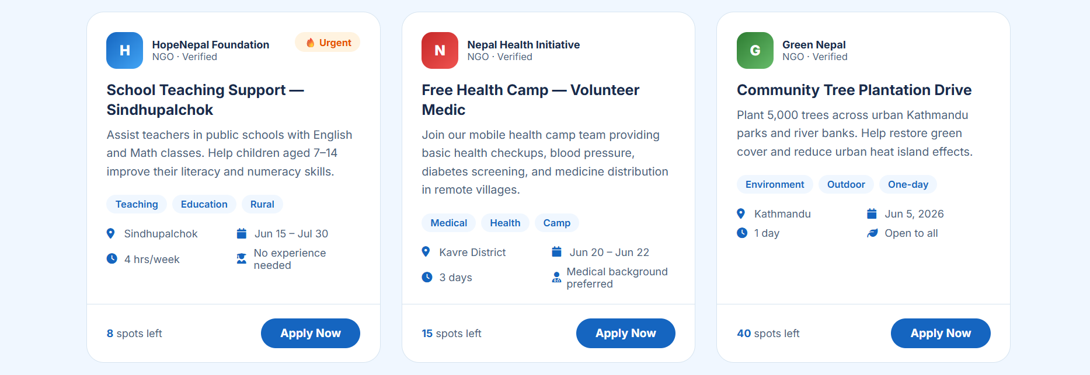
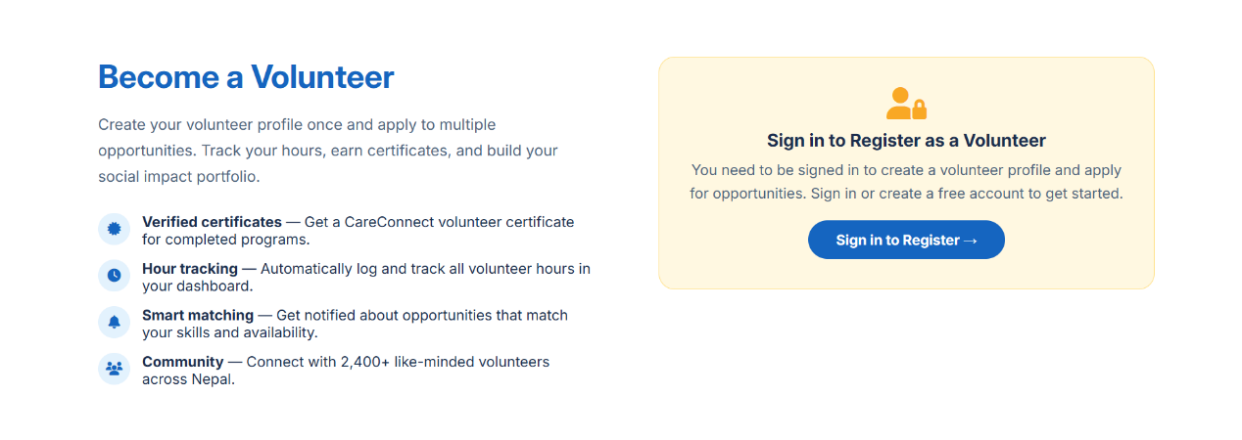
Figure 7: Volunteer Page

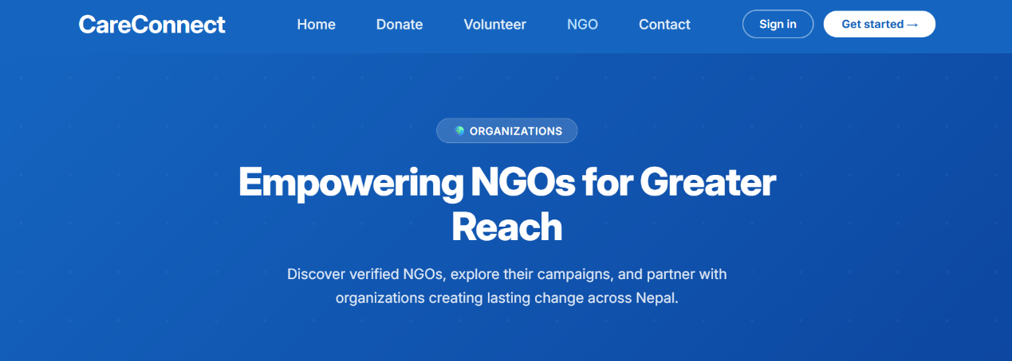
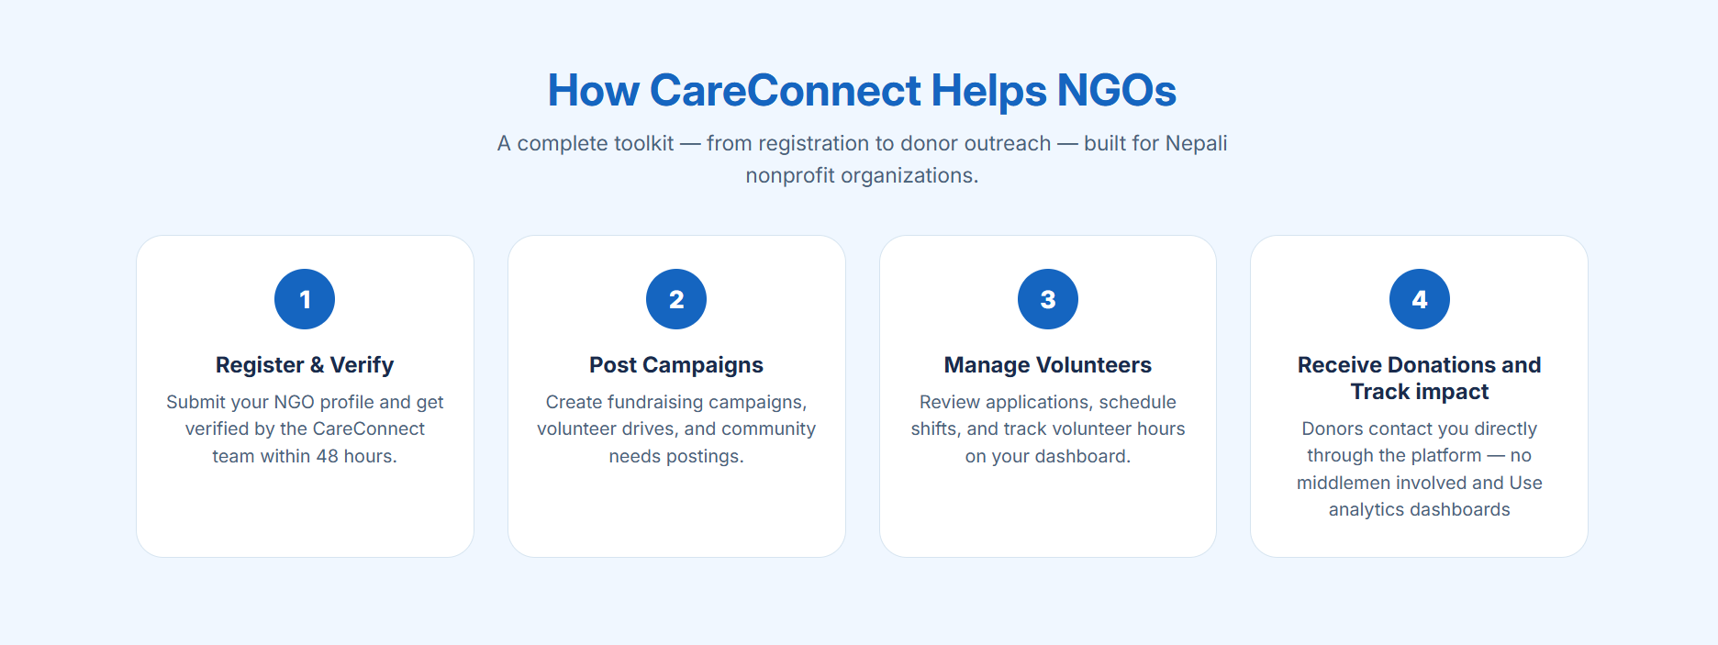
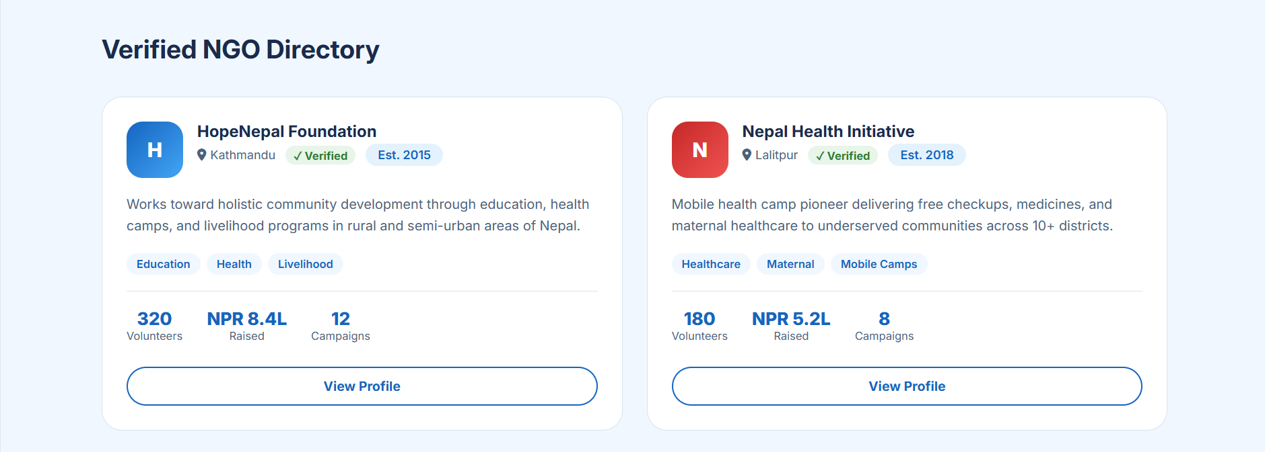
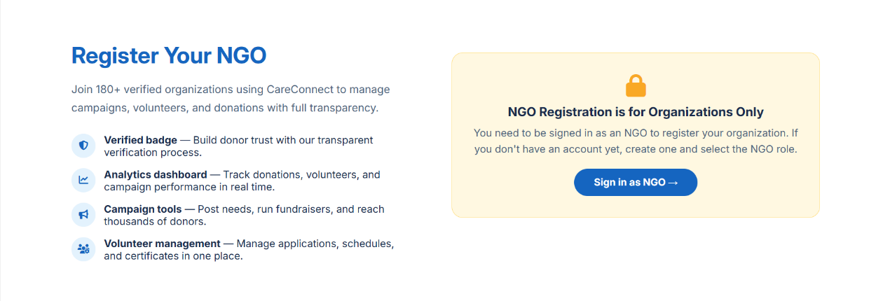
Figure 8: NGO Page
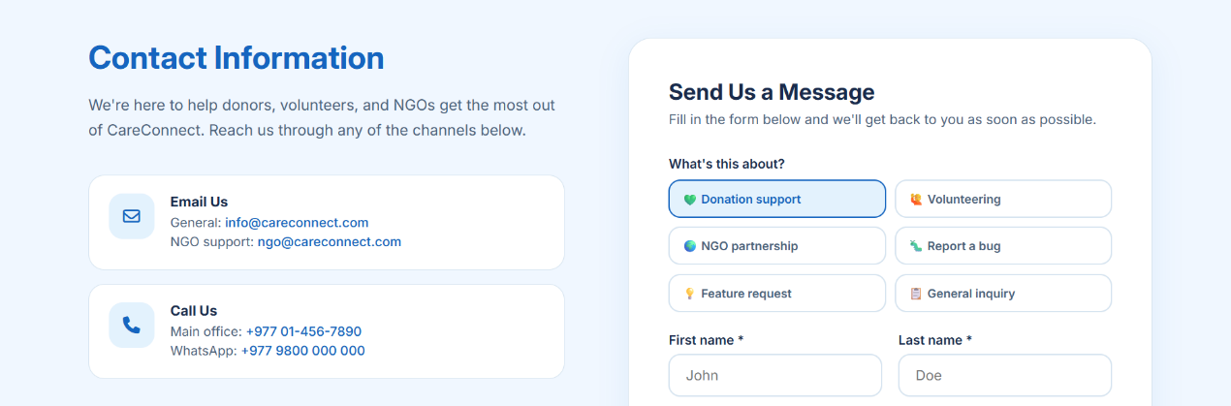
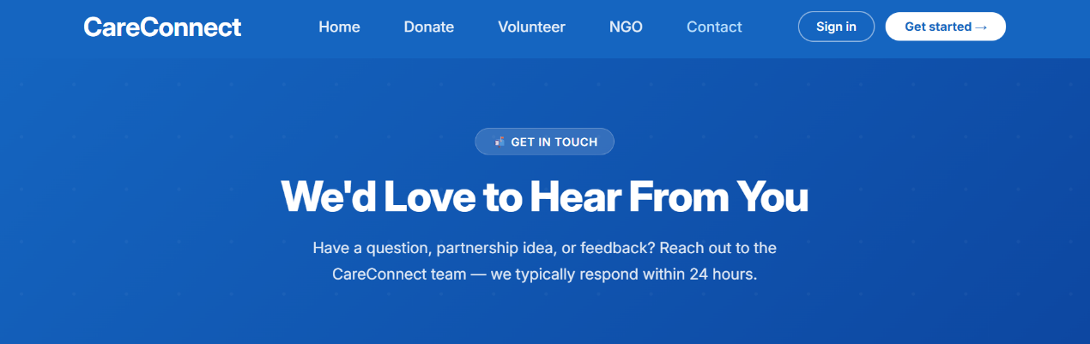
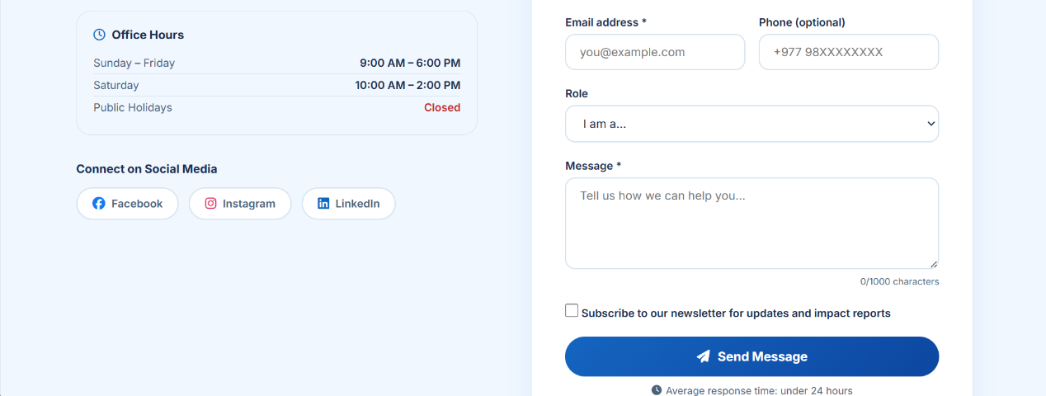
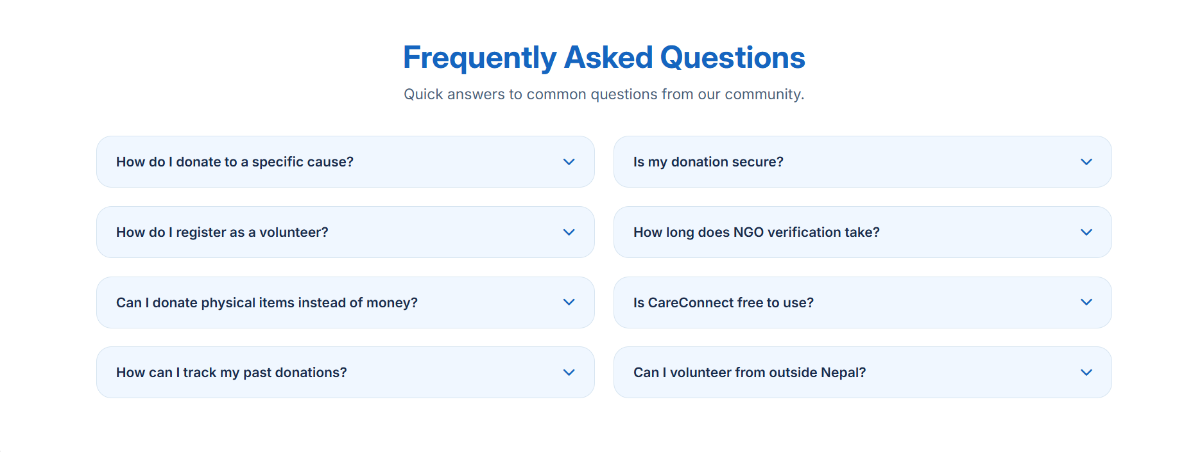
Figure 9: Contact Page
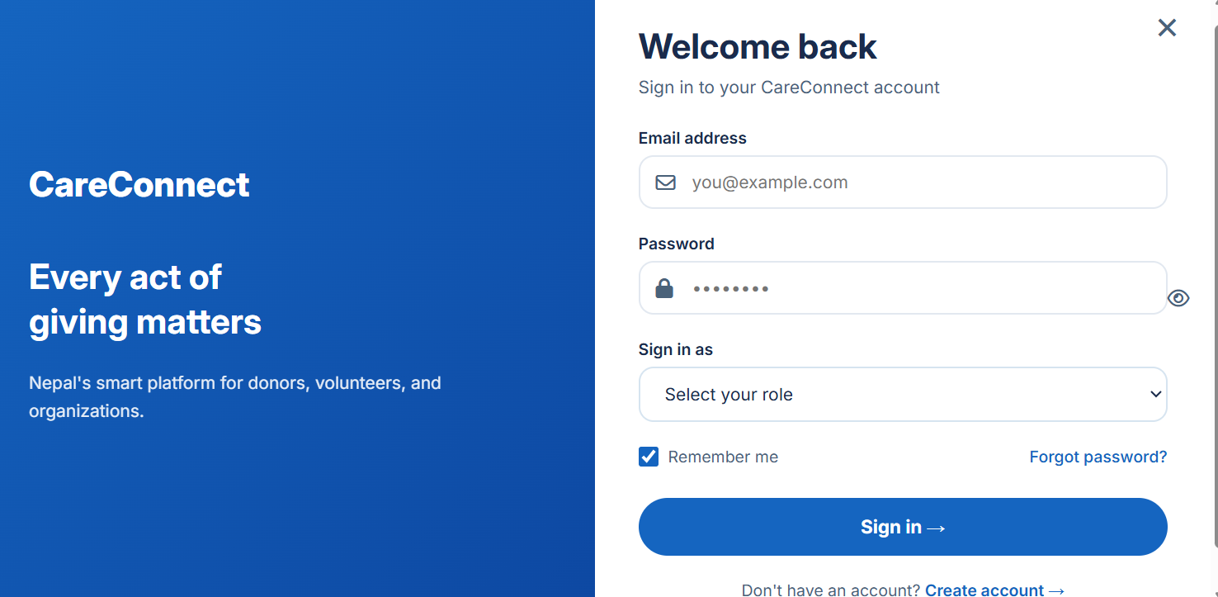
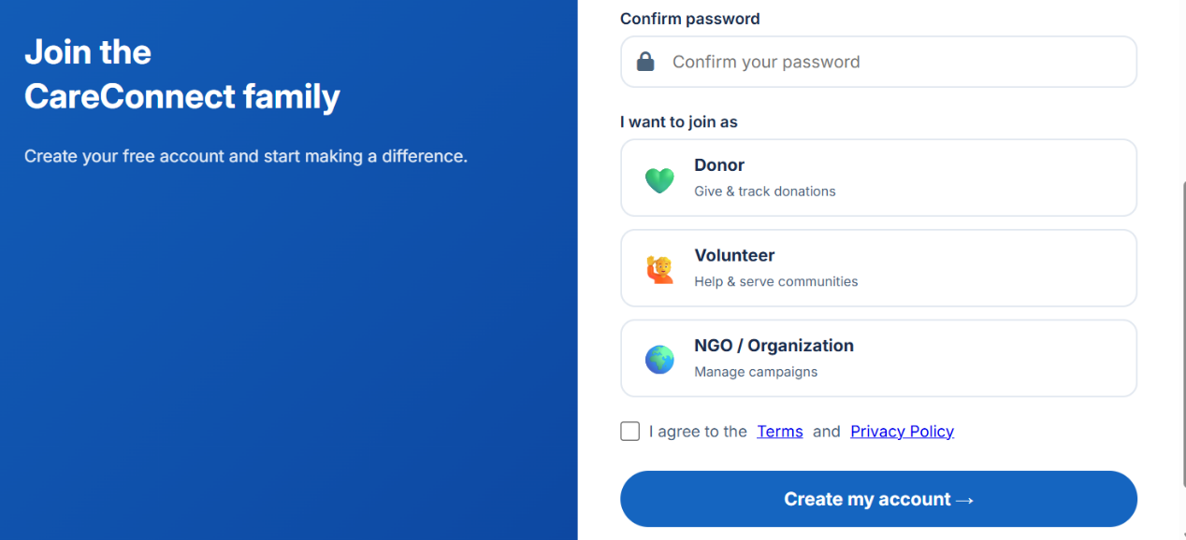
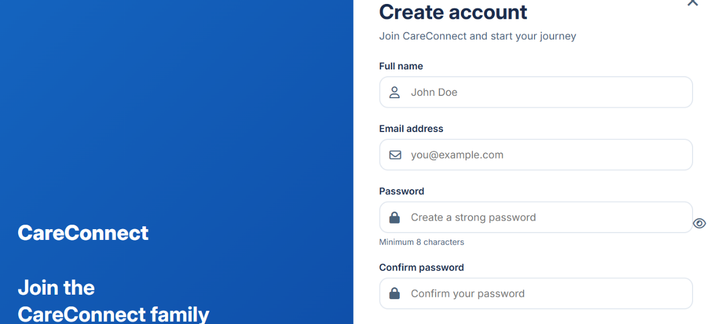
Figure 11: Sign in module
Figure 10: Sign Up Module

References
- GoFundMe. (2026). Online Crowdfunding Platform. https://www.gofundme.com/
- VolunteerMatch. (2026). Volunteer Opportunity Platform. https://www.volunteermatch.org/
- Salesforce. (2026). Nonprofit Cloud Solutions. https://www.salesforce.com/solutions/nonprofit/
- Charity Navigator. (2026). Nonprofit Organization Ratings and Evaluation. https://www.charitynavigator.org/
- Pressman, R. S. (2014). Software Engineering: A Practitioner’s Approach. McGraw-Hill Education.
- Sommerville, I. (2015). Software Engineering (10th ed.). Pearson.

